The following table lists the electrode placements for the 12 leads Readings.

|  |  |  |  |
| --- | --- | --- | --- |
| **LEAD** | **RED** | **YELLOW** | **GREEN** |
| **I** | RA | LA | RL |
| **II** | RA | LL | RL |
| **III** | LA | LL | RL |
| **aVR** | LA/LL1 | RA | RL |
| **aVL** | RA/LL1 | LA | RL |
| **aVF** | RA/LA1 | LL | RL |
| **V1** | RL | v1 | LL |
| **V2** | RL | v2 | LL |
| **V3** | RL | v3 | LL |
| **V4** | RL | v4 | LL |
| **V5** | RL | v5 | LL |
| **V6** | RL | v6 | LL |

**Body Positions**

* RA2 - right arm
* LA2 - left arm
* RL2 - right leg
* LL2 - left leg
* v1 - v6 (see diagram below)

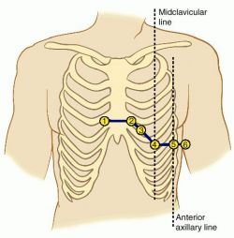

* 1 Put two electrodes at the indicated locations and connect them together via a cable.
* 2 Limb electrode (RA, LA, LL, RL) can be placed anywhere on the limb as long as it is at least 4 inches away from the heart.